Park West School
School Supply List 2023-2024
Grade: One (1)

To assist you in purchasing school supplies for your child we have prepared this list of materials
for your consideration:

3 | Crayons – pack of 24 (Crayola preferred)
24 | Sharpened pencils (dollar store brand NOT recommended as they do not sharpen well)
1 | Pencil sharpener with cover
3 | White erasers
1 | Blunt tip kids scissors (with metal blade)
6 | Glue sticks – large size (20g) recommended as the small ones do not last long. Dollar store brand NOT recommended.
1 | Hard plastic pencil case **see attached picture
1 | Washable markers
1 | Duo tang with pockets – not plastic (red preferred) **see attached picture
2 | Duo tang without pockets – not plastic (yellow and orange preferred)
1 | Pocket folder – plastic (green preferred)
2 | Sketchbook – available at Dollarama
1 | Nylon zippered courier bag – available at Dollarama **see attached picture
4 | Ruled exercise scribblers 32 pages (1 blue, 1 green, 1 yellow, 1 pink preferred) **see attached picture
2 | Scribblers – 1/2 interlined, 1/2 blank page (Hilroy green – it has dotted lines between the solid lines to help with letter sizing/placement) **see attached picture
1 | Composition Notebook – available at Dollarama **see attached picture
8 | Whiteboard markers – fine tip (black please as the other colours can stain the whiteboards) **see attached picture
1 | Whiteboard eraser – a clean old sock or small baby wash cloth can be used
3 | Plah-doh (full size containers)
4 | Large Freezer Ziploc type baggies
1 | Indoor shoes with non-marking soles to keep at school – please do not send lace up shoes if your child cannot tie
Optional/Suggested Items:
-2 boxes of facial tissues
-1 small package of unscented baby wipes
-1 roll of paper towel
•Re-use previous year supplies if you can- no need to buy new if you have items that are in usable condition (binders, duo tangs, pencils, coloured pencils, scissors, kitbox, etc,).
•It is not necessary to provide quantities of requested items for the entire school year on the first day of school.
•Please label all materials before sending to school.
Please note, there may be specific items requested throughout the year by individual teachers to complete subject-specific projects and/or assignments.
Fine Tip Black Whiteboard Markers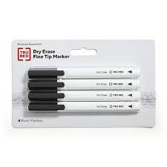

Nylon Zippered Courier Bag (colour doesn’t matter)
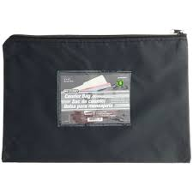
Duo Tang with Pockets (has 3 metal fasteners), not plastic
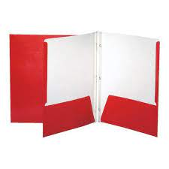

Hilroy Green Journal (1/2 interlined, 1/2 blank page) 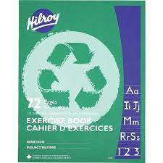

Ruled exercise scribblers 32 pages (1 of each colour)
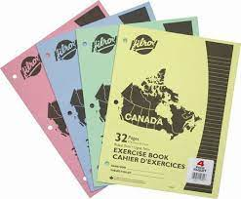
Plastic Pencil Case (colour doesn’t matter)
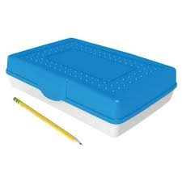

Composition Notebook (colour doesn’t matter)
